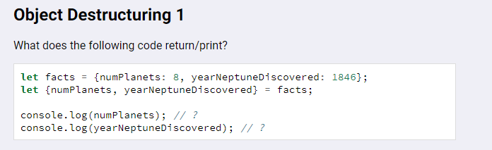

numPlanets = 8

yearNeptuneDiscovered = 1846

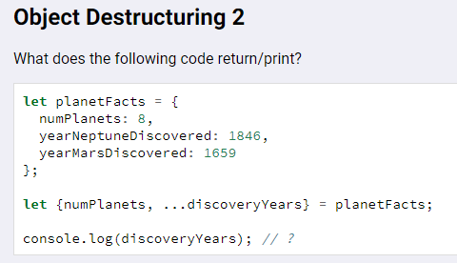

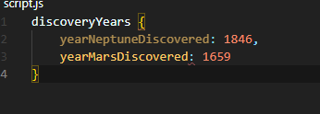

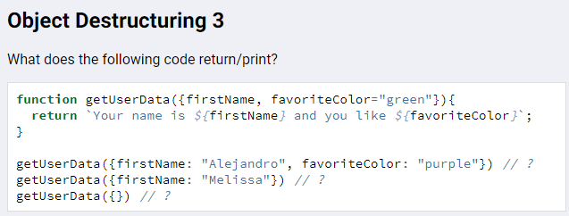

getUserData({firstName: "Alejandro", favoriteColor: "purple"})

“Your name is Alejandro and you like purple”

getUserData({firstName: "Melissa"})

“Your name is Melissa and you like green”

getUserData({})

“Your name is undefined and you like green”

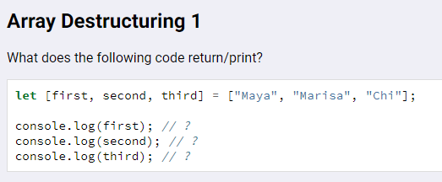

Maya

Marisa

Chi

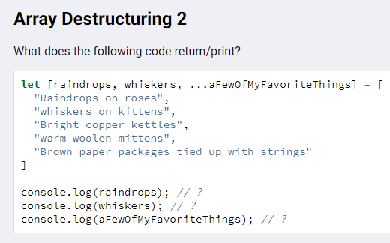

1. ‘Raindrops on roses’
2. ‘whiskers on kittens’
3. [‘Bright copper kettles’, ‘warm woolen mittens’, Brown paper packages tied up with strings’]

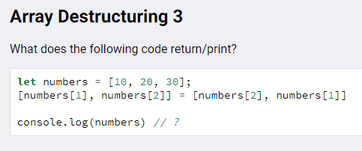

[10, 30, 20] because of the swap between indices

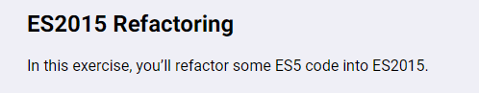

See Script.js file in Repo for these.